**Bài tập tuần 5**

**Thực hành 1: Tạo và kết nối CSDL ngay bên trong Project Winform.**

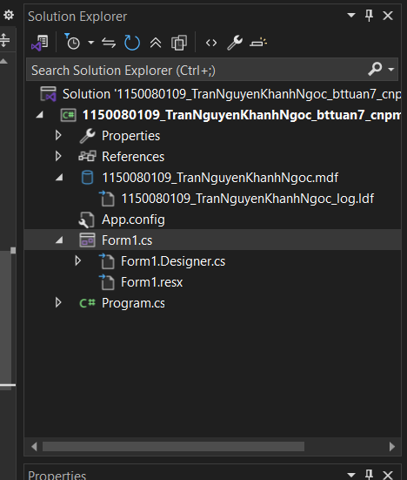

**Thực hành 2: Thêm dữ liệu không dùng Parameter.**

Tạo winform

Code file Form1.Designer.cs

namespace _1150080109_TranNguyenKhanhNgoc_bttuan7_cnpm2

{

partial class Form1

{

/// <summary>

/// Required designer variable.

/// </summary>

private System.ComponentModel.IContainer components = null;

/// <summary>

/// Clean up any resources being used.

/// </summary>

/// <param name="disposing">true if managed resources should be disposed; otherwise, false.</param>

protected override void Dispose(bool disposing)

{

if (disposing && (components != null))

{

components.Dispose();

}

base.Dispose(disposing);

}

#region Windows Form Designer generated code

private void InitializeComponent()

{

this.grpNhapThongTin = new System.Windows.Forms.GroupBox();

this.dtpNgaySinh = new System.Windows.Forms.DateTimePicker();

this.cboGioiTinh = new System.Windows.Forms.ComboBox();

this.txtMaLop = new System.Windows.Forms.TextBox();

this.txtQueQuan = new System.Windows.Forms.TextBox();

this.txtTenSV = new System.Windows.Forms.TextBox();

this.txtMaSV = new System.Windows.Forms.TextBox();

this.btnThem = new System.Windows.Forms.Button();

this.lblMaLop = new System.Windows.Forms.Label();

this.lblQueQuan = new System.Windows.Forms.Label();

this.lblNgaySinh = new System.Windows.Forms.Label();

this.lblGioiTinh = new System.Windows.Forms.Label();

this.lblTenSV = new System.Windows.Forms.Label();

this.lblMaSV = new System.Windows.Forms.Label();

this.grpDanhSach = new System.Windows.Forms.GroupBox();

this.dgvSinhVien = new System.Windows.Forms.DataGridView();

this.MaSV = new System.Windows.Forms.DataGridViewTextBoxColumn();

this.TenSV = new System.Windows.Forms.DataGridViewTextBoxColumn();

this.GioiTinh = new System.Windows.Forms.DataGridViewTextBoxColumn();

this.NgaySinh = new System.Windows.Forms.DataGridViewTextBoxColumn();

this.QueQuan = new System.Windows.Forms.DataGridViewTextBoxColumn();

this.MaLop = new System.Windows.Forms.DataGridViewTextBoxColumn();

this.grpNhapThongTin.SuspendLayout();

this.grpDanhSach.SuspendLayout();

((System.ComponentModel.ISupportInitialize)(this.dgvSinhVien)).BeginInit();

this.SuspendLayout();

//

// grpNhapThongTin

//

this.grpNhapThongTin.Controls.Add(this.dtpNgaySinh);

this.grpNhapThongTin.Controls.Add(this.cboGioiTinh);

this.grpNhapThongTin.Controls.Add(this.txtMaLop);

this.grpNhapThongTin.Controls.Add(this.txtQueQuan);

this.grpNhapThongTin.Controls.Add(this.txtTenSV);

this.grpNhapThongTin.Controls.Add(this.txtMaSV);

this.grpNhapThongTin.Controls.Add(this.btnThem);

this.grpNhapThongTin.Controls.Add(this.lblMaLop);

this.grpNhapThongTin.Controls.Add(this.lblQueQuan);

this.grpNhapThongTin.Controls.Add(this.lblNgaySinh);

this.grpNhapThongTin.Controls.Add(this.lblGioiTinh);

this.grpNhapThongTin.Controls.Add(this.lblTenSV);

this.grpNhapThongTin.Controls.Add(this.lblMaSV);

this.grpNhapThongTin.Location = new System.Drawing.Point(12, 12);

this.grpNhapThongTin.Name = "grpNhapThongTin";

this.grpNhapThongTin.Size = new System.Drawing.Size(310, 350);

this.grpNhapThongTin.TabIndex = 0;

this.grpNhapThongTin.TabStop = false;

this.grpNhapThongTin.Text = "Nhập thông tin:";

//

// dtpNgaySinh

//

this.dtpNgaySinh.Format = System.Windows.Forms.DateTimePickerFormat.Short;

this.dtpNgaySinh.Location = new System.Drawing.Point(120, 155);

this.dtpNgaySinh.Name = "dtpNgaySinh";

this.dtpNgaySinh.Size = new System.Drawing.Size(160, 23);

this.dtpNgaySinh.TabIndex = 6;

//

// cboGioiTinh

//

this.cboGioiTinh.DropDownStyle = System.Windows.Forms.ComboBoxStyle.DropDownList;

this.cboGioiTinh.FormattingEnabled = true;

this.cboGioiTinh.Items.AddRange(new object[] {

"Nam",

"Nữ"});

this.cboGioiTinh.Location = new System.Drawing.Point(120, 115);

this.cboGioiTinh.Name = "cboGioiTinh";

this.cboGioiTinh.Size = new System.Drawing.Size(160, 23);

this.cboGioiTinh.TabIndex = 5;

//

// txtMaLop

//

this.txtMaLop.Location = new System.Drawing.Point(120, 235);

this.txtMaLop.Name = "txtMaLop";

this.txtMaLop.Size = new System.Drawing.Size(160, 23);

this.txtMaLop.TabIndex = 8;

//

// txtQueQuan

//

this.txtQueQuan.Location = new System.Drawing.Point(120, 195);

this.txtQueQuan.Name = "txtQueQuan";

this.txtQueQuan.Size = new System.Drawing.Size(160, 23);

this.txtQueQuan.TabIndex = 7;

//

// txtTenSV

//

this.txtTenSV.Location = new System.Drawing.Point(120, 75);

this.txtTenSV.Name = "txtTenSV";

this.txtTenSV.Size = new System.Drawing.Size(160, 23);

this.txtTenSV.TabIndex = 4;

//

// txtMaSV

//

this.txtMaSV.Location = new System.Drawing.Point(120, 35);

this.txtMaSV.Name = "txtMaSV";

this.txtMaSV.Size = new System.Drawing.Size(160, 23);

this.txtMaSV.TabIndex = 3;

//

// btnThem

//

this.btnThem.Location = new System.Drawing.Point(120, 280);

this.btnThem.Name = "btnThem";

this.btnThem.Size = new System.Drawing.Size(160, 30);

this.btnThem.TabIndex = 9;

this.btnThem.Text = "Thêm sinh viên";

this.btnThem.UseVisualStyleBackColor = true;

this.btnThem.Click += new System.EventHandler(this.btnThem_Click);

//

// lblMaLop

//

this.lblMaLop.AutoSize = true;

this.lblMaLop.Location = new System.Drawing.Point(20, 238);

this.lblMaLop.Name = "lblMaLop";

this.lblMaLop.Size = new System.Drawing.Size(50, 15);

this.lblMaLop.TabIndex = 0;

this.lblMaLop.Text = "Mã lớp:";

//

// lblQueQuan

//

this.lblQueQuan.AutoSize = true;

this.lblQueQuan.Location = new System.Drawing.Point(20, 198);

this.lblQueQuan.Name = "lblQueQuan";

this.lblQueQuan.Size = new System.Drawing.Size(64, 15);

this.lblQueQuan.TabIndex = 0;

this.lblQueQuan.Text = "Quê quán:";

//

// lblNgaySinh

//

this.lblNgaySinh.AutoSize = true;

this.lblNgaySinh.Location = new System.Drawing.Point(20, 158);

this.lblNgaySinh.Name = "lblNgaySinh";

this.lblNgaySinh.Size = new System.Drawing.Size(67, 15);

this.lblNgaySinh.TabIndex = 0;

this.lblNgaySinh.Text = "Ngày sinh:";

//

// lblGioiTinh

//

this.lblGioiTinh.AutoSize = true;

this.lblGioiTinh.Location = new System.Drawing.Point(20, 118);

this.lblGioiTinh.Name = "lblGioiTinh";

this.lblGioiTinh.Size = new System.Drawing.Size(57, 15);

this.lblGioiTinh.TabIndex = 0;

this.lblGioiTinh.Text = "Giới tính:";

//

// lblTenSV

//

this.lblTenSV.AutoSize = true;

this.lblTenSV.Location = new System.Drawing.Point(20, 78);

this.lblTenSV.Name = "lblTenSV";

this.lblTenSV.Size = new System.Drawing.Size(74, 15);

this.lblTenSV.TabIndex = 0;

this.lblTenSV.Text = "Tên sinh viên:";

//

// lblMaSV

//

this.lblMaSV.AutoSize = true;

this.lblMaSV.Location = new System.Drawing.Point(20, 38);

this.lblMaSV.Name = "lblMaSV";

this.lblMaSV.Size = new System.Drawing.Size(78, 15);

this.lblMaSV.TabIndex = 0;

this.lblMaSV.Text = "Mã sinh viên:";

//

// grpDanhSach

//

this.grpDanhSach.Controls.Add(this.dgvSinhVien);

this.grpDanhSach.Location = new System.Drawing.Point(340, 12);

this.grpDanhSach.Name = "grpDanhSach";

this.grpDanhSach.Size = new System.Drawing.Size(480, 350);

this.grpDanhSach.TabIndex = 1;

this.grpDanhSach.TabStop = false;

this.grpDanhSach.Text = "Danh sách sinh viên:";

//

// dgvSinhVien

//

this.dgvSinhVien.AllowUserToAddRows = false;

this.dgvSinhVien.ColumnHeadersHeightSizeMode = System.Windows.Forms.DataGridViewColumnHeadersHeightSizeMode.AutoSize;

this.dgvSinhVien.Columns.AddRange(new System.Windows.Forms.DataGridViewColumn[] {

this.MaSV,

this.TenSV,

this.GioiTinh,

this.NgaySinh,

this.QueQuan,

this.MaLop});

this.dgvSinhVien.Location = new System.Drawing.Point(15, 25);

this.dgvSinhVien.Name = "dgvSinhVien";

this.dgvSinhVien.RowHeadersVisible = false;

this.dgvSinhVien.RowTemplate.Height = 25;

this.dgvSinhVien.Size = new System.Drawing.Size(450, 300);

this.dgvSinhVien.TabIndex = 0;

//

// MaSV

//

this.MaSV.HeaderText = "Mã SV";

this.MaSV.Name = "MaSV";

//

// TenSV

//

this.TenSV.HeaderText = "Tên SV";

this.TenSV.Name = "TenSV";

//

// GioiTinh

//

this.GioiTinh.HeaderText = "Giới tính";

this.GioiTinh.Name = "GioiTinh";

//

// NgaySinh

//

this.NgaySinh.HeaderText = "Ngày sinh";

this.NgaySinh.Name = "NgaySinh";

//

// QueQuan

//

this.QueQuan.HeaderText = "Quê quán";

this.QueQuan.Name = "QueQuan";

//

// MaLop

//

this.MaLop.HeaderText = "Mã lớp";

this.MaLop.Name = "MaLop";

//

// Form1

//

this.AutoScaleDimensions = new System.Drawing.SizeF(7F, 15F);

this.AutoScaleMode = System.Windows.Forms.AutoScaleMode.Font;

this.ClientSize = new System.Drawing.Size(834, 381);

this.Controls.Add(this.grpDanhSach);

this.Controls.Add(this.grpNhapThongTin);

this.Name = "Form1";

this.Text = "Thêm dữ liệu không dùng Parameter";

this.Load += new System.EventHandler(this.Form1_Load);

this.grpNhapThongTin.ResumeLayout(false);

this.grpNhapThongTin.PerformLayout();

this.grpDanhSach.ResumeLayout(false);

((System.ComponentModel.ISupportInitialize)(this.dgvSinhVien)).EndInit();

this.ResumeLayout(false);

}

#endregion

private System.Windows.Forms.GroupBox grpNhapThongTin;

private System.Windows.Forms.Label lblMaSV;

private System.Windows.Forms.Label lblTenSV;

private System.Windows.Forms.Label lblGioiTinh;

private System.Windows.Forms.Label lblNgaySinh;

private System.Windows.Forms.Label lblQueQuan;

private System.Windows.Forms.Label lblMaLop;

private System.Windows.Forms.TextBox txtMaSV;

private System.Windows.Forms.TextBox txtTenSV;

private System.Windows.Forms.ComboBox cboGioiTinh;

private System.Windows.Forms.DateTimePicker dtpNgaySinh;

private System.Windows.Forms.TextBox txtQueQuan;

private System.Windows.Forms.TextBox txtMaLop;

private System.Windows.Forms.Button btnThem;

private System.Windows.Forms.GroupBox grpDanhSach;

private System.Windows.Forms.DataGridView dgvSinhVien;

private System.Windows.Forms.DataGridViewTextBoxColumn MaSV;

private System.Windows.Forms.DataGridViewTextBoxColumn TenSV;

private System.Windows.Forms.DataGridViewTextBoxColumn GioiTinh;

private System.Windows.Forms.DataGridViewTextBoxColumn NgaySinh;

private System.Windows.Forms.DataGridViewTextBoxColumn QueQuan;

private System.Windows.Forms.DataGridViewTextBoxColumn MaLop;

}

}

Code chức năng trong Form1.cs

using System;

using System.Collections.Generic;

using System.ComponentModel;

using System.Data;

using System.Data.SqlClient;

using System.Drawing;

using System.Linq;

using System.Text;

using System.Threading.Tasks;

using System.Windows.Forms;

namespace _1150080109_TranNguyenKhanhNgoc_bttuan7_cnpm2

{

public partial class Form1 : Form

{

SqlConnection conn;

SqlDataAdapter da;

DataTable dt;

public Form1()

{

InitializeComponent();

}

private void Form1_Load(object sender, EventArgs e)

{

conn = new SqlConnection(@"Data Source=(LocalDB)\MSSQLLocalDB;

AttachDbFilename=C:\Users\trang\source\repos\1150080109_TranNguyenKhanhNgoc_bttuan7_cnpm2\1150080109_TranNguyenKhanhNgoc_bttuan7_cnpm2\1150080109_TranNguyenKhanhNgoc.mdf;

Integrated Security=True");

HienThiDanhSach();

}

private void HienThiDanhSach()

{

da = new SqlDataAdapter("SELECT * FROM SinhVien", conn);

dt = new DataTable();

da.Fill(dt);

dgvSinhVien.DataSource = dt;

}

private void btnThem_Click(object sender, EventArgs e)

{

try

{

string maSV = txtMaSV.Text;

string tenSV = txtTenSV.Text;

string gioiTinh = cboGioiTinh.Text;

string ngaySinh = dtpNgaySinh.Value.ToString("yyyy-MM-dd");

string queQuan = txtQueQuan.Text;

string maLop = txtMaLop.Text;

// ❌ Không dùng Parameter (cách lỗi thời, chỉ để học)

string sql = "INSERT INTO SinhVien VALUES('" + maSV + "', N'" + tenSV + "', N'" +

gioiTinh + "', '" + ngaySinh + "', N'" + queQuan + "', '" + maLop + "')";

SqlCommand cmd = new SqlCommand(sql, conn);

conn.Open();

cmd.ExecuteNonQuery();

conn.Close();

MessageBox.Show("Thêm sinh viên thành công!");

HienThiDanhSach();

}

catch (Exception ex)

{

MessageBox.Show("Lỗi: " + ex.Message);

conn.Close();

}

}

}

}

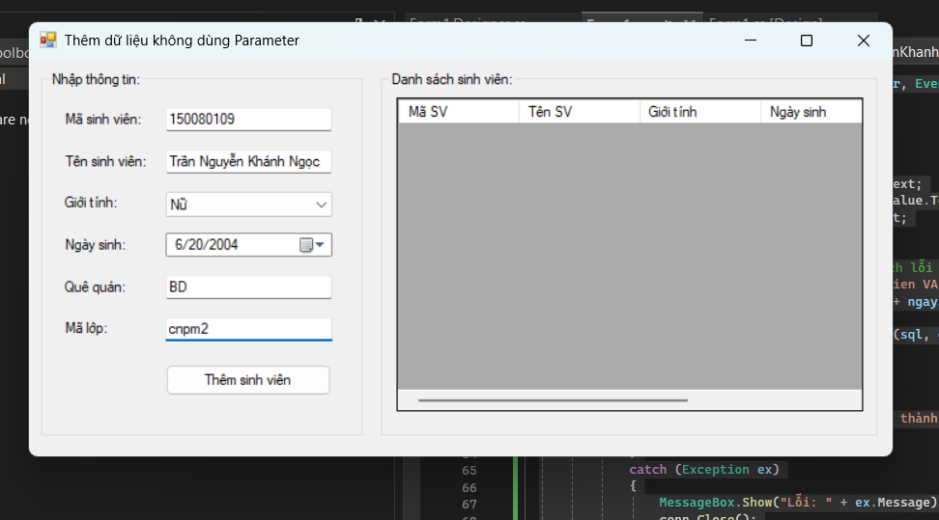

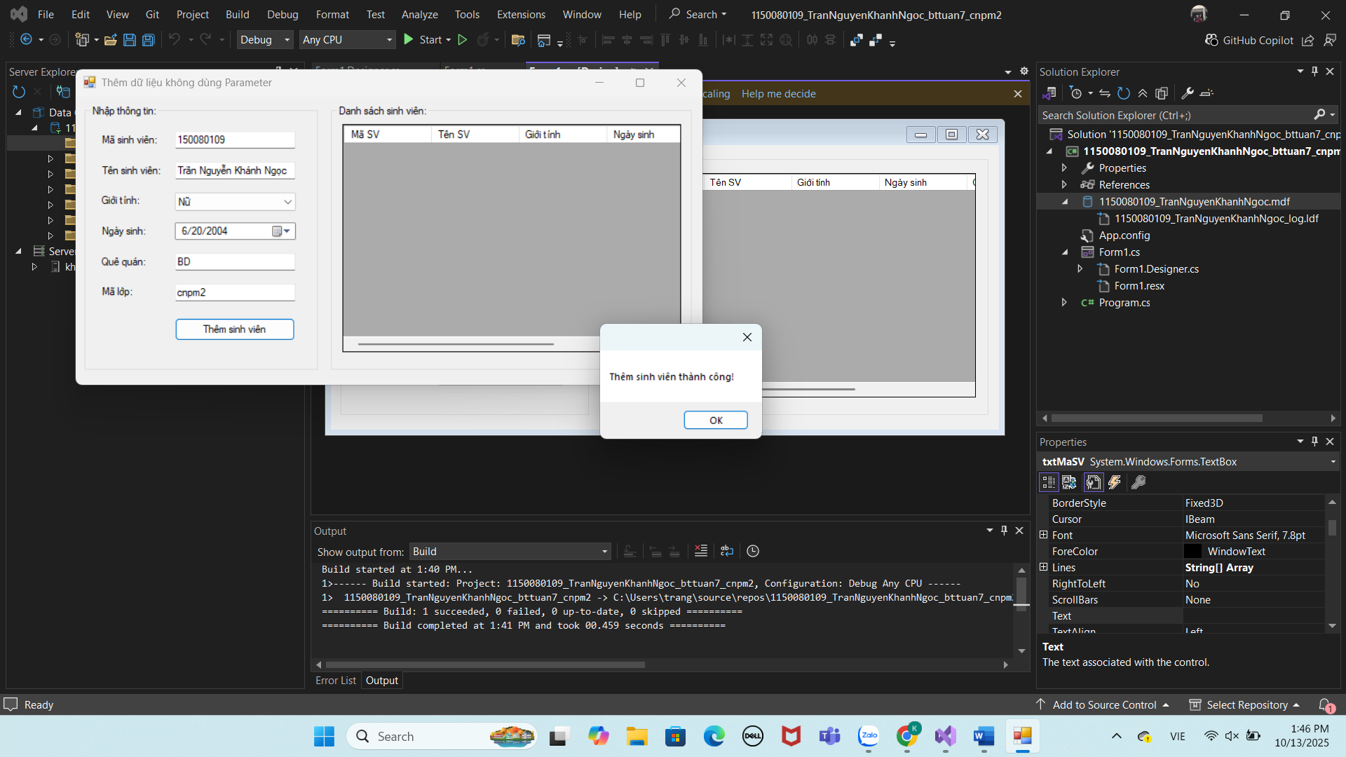

Thực hành 3: Sửa dữ liệu không dùng Parameter.

